**Documentations:**

**About the data Set (HousingPrices-Amsterdam-August-2021)**

1. **Importing Libraries**

**Python Code**

import pandas as pd

import numpy as np

import seaborn as sns

import matplotlib.pyplot as plt

%matplotlib inline

In this section, the necessary libraries for the data analysis are imported, including Pandas, NumPy, Seaborn, and Matplotlib. `%matplotlib inline` is a magic command in Jupyter Notebook to display plots directly in the notebook.

---

1. **Loading Data**

**Python Code**

df = pd.read_csv("HousingPrices-Amsterdam-August-2021.csv")

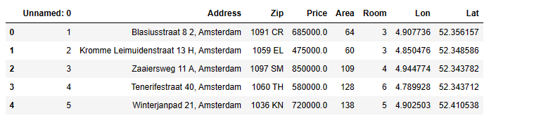

The dataset is loaded into a Pandas DataFrame called `df` from a CSV file.

---

1. **Renaming and Dropping Columns**

**Python Code**

df.rename(columns={"Unnamed: 0": "index"}, inplace=True)

df.drop(columns={"index", "Address", "Zip"}, inplace=True)

The "Unnamed: 0" column is renamed to "index" and the "index," "Address," and "Zip" columns are dropped as they are considered unnecessary for the analysis.

---

1. **Checking Data Information**

**Python Code**

df.info()

Data types and null values in the DataFrame are checked using the `.info()` method and displayed.

---

1. **Visualizing Missing Values**

**Python Code**

sns.heatmap(df.isnull(), yticklabels=False, cbar=False, cmap='viridis')

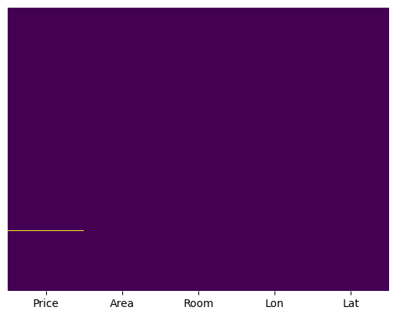

A heatmap is created to visualize missing values in the dataset using Seaborn's heatmap function.

---

1. **Exploratory Data Analysis (EDA)**

**Python Code**

sns.heatmap(df.corr(), annot=True)

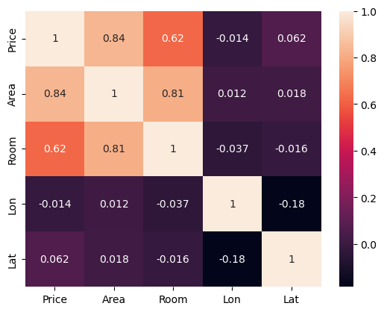

A heatmap is created to visualize the correlation between different columns in the dataset.

**Python Code**

sns.pairplot(df)

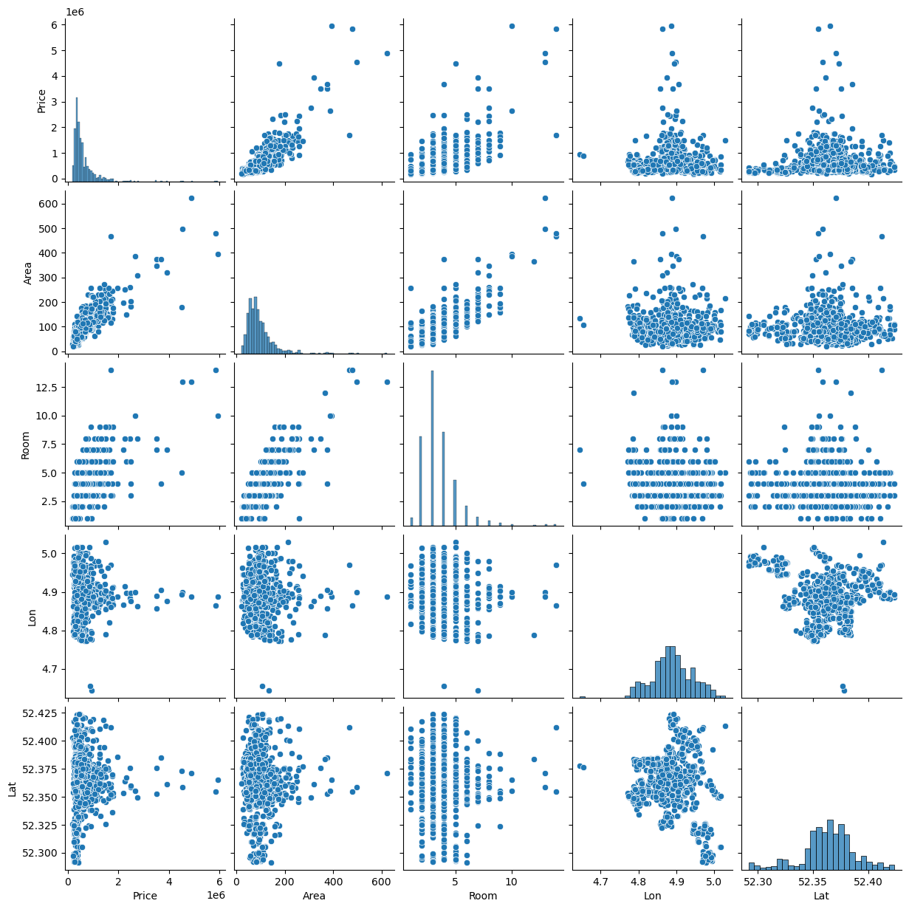

A pairplot is generated to explore relationships between variables in the dataset.

**Python Code**

sns.histplot(df["Price"])

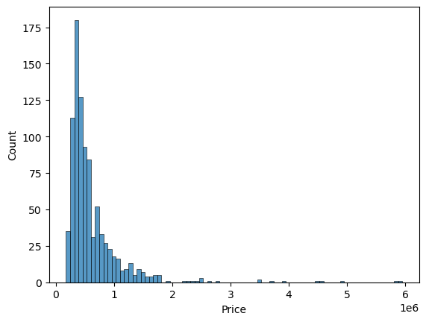

A histogram is created to visualize the distribution of prices in the dataset.

---

1. **Data Normalization**

Data normalization is performed on the "Price" column by removing outliers using the IQR method. Outliers are identified, the IQR is calculated, and a threshold for outliers is defined. Data points with prices above this threshold are removed.

**Python code**

q1 = df.describe()['Price']['25%']

q3 = df.describe()['Price']['75%']

iqr = q3 - q1

max_price = q3 + 1.5 * iqr

max_price

outlier = df[df['Price'] >= max_price]

outliers_count = outlier['Price'].count()

data_count = df['Price'].count()

print('Percentage removed: ' + str(round(outliers_count/data_count * 100, 2)) + '%')

df= df[df['Price'] <= max_price]

---

1. **Visualizing Normalized Data**

**Python Code**

sns.histplot(df["Price"])

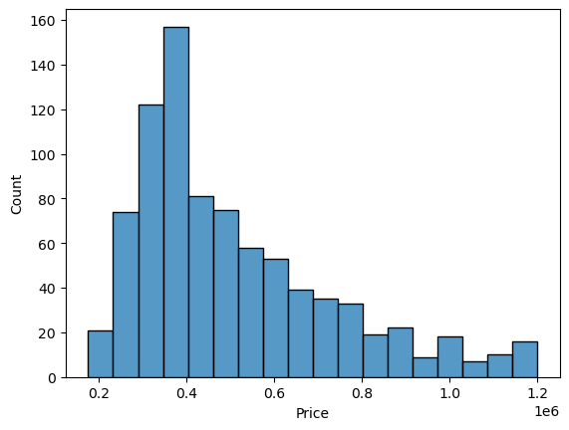

A histogram is created to visualize the distribution of prices after normalizing the "Price" column.

---

1. **Further EDA**

**Python Code**

sns.pairplot(df)

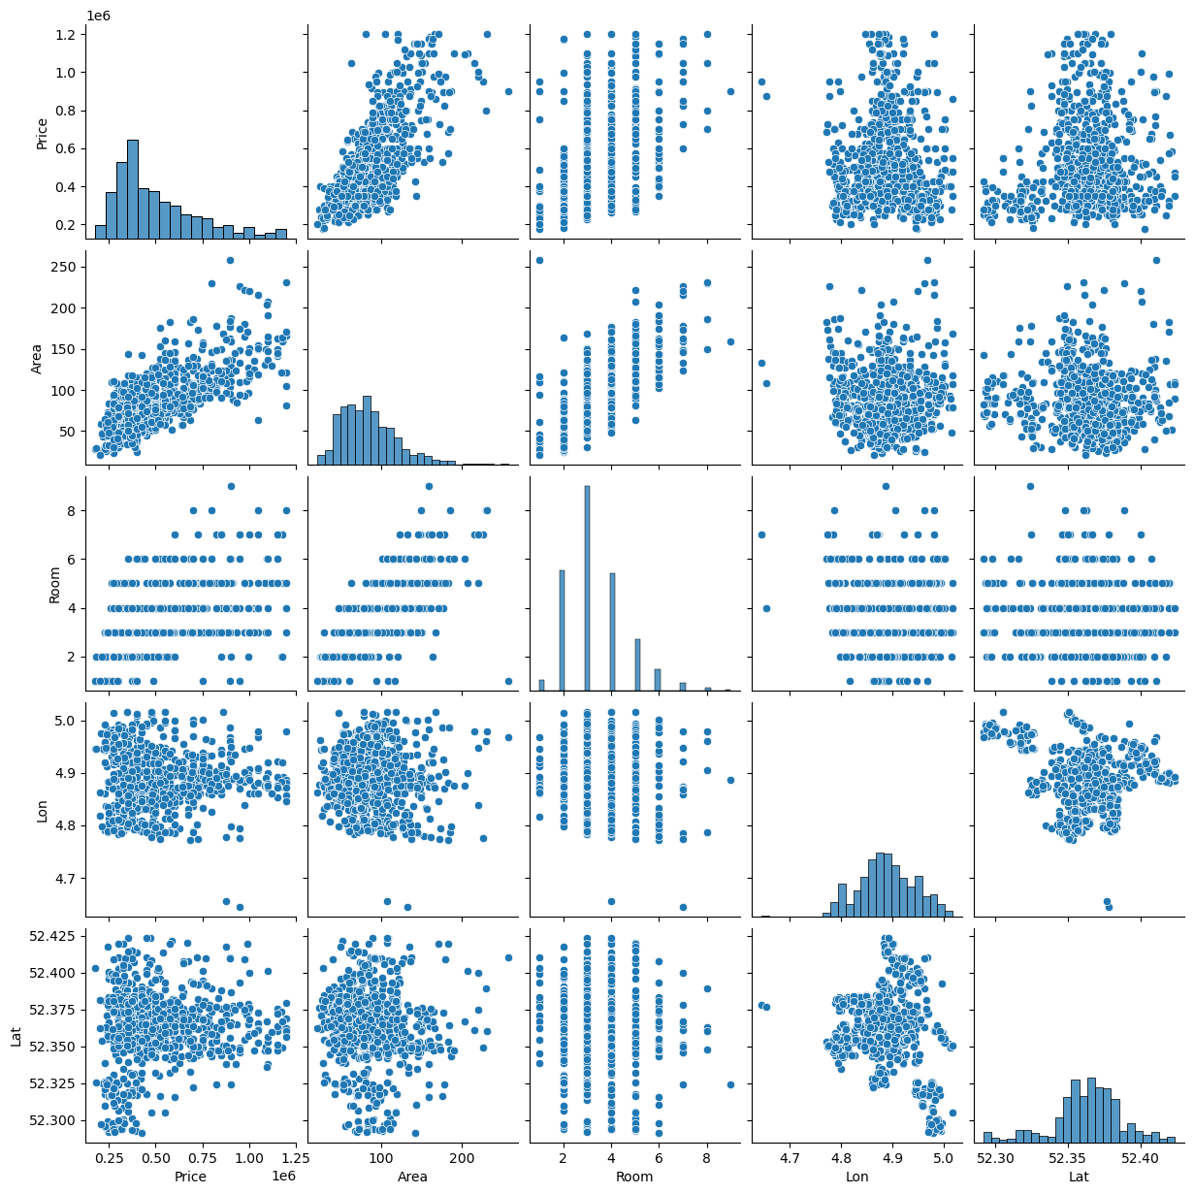

Another pairplot is generated to explore relationships between variables after removing outliers.

---

1. **Splitting the Data**

The data is split into features (X) and the target variable (Y) and prepared for model training.

**Python Code**

from sklearn.model_selection import train_test_split

X_train, X_test, y_train, y_test = train_test_split(X, Y, test_size=0.2)

---

1. **Model Training**

**Python Code**

from sklearn.linear_model import LinearRegression

lm = LinearRegression()

lm.fit(X_train, y_train)

A linear regression model is trained using scikit-learn.

---

1. **Model Evaluation**

**Python Code**

print(lm.intercept_)

The intercept of the linear regression model is printed.

1. **Interpreting the Coefficients**

**Python Code**

coef=pd.DataFrame(lm.coef_,X.columns,columns=["Coefficient"])

coef

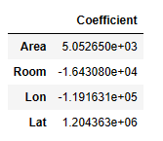

1. Area Coefficient (5.052650e+03): This coefficient suggests that, on average, for every unit increase in the area of the property the price is expected to increase by approximately 5052.65 units, holding other variables constant.
2. Room Coefficient (-1.643080e+04): This coefficient suggests that, on average, for every additional room in the property, the price is expected to decrease by approximately 16430.8 units, holding other variables constant. A negative coefficient here indicates that more rooms are associated with lower prices.
3. Lon Coefficient (-1.191631e+05): This coefficient suggests that, on average, for every unit increase in longitude, the price is expected to decrease by approximately 119163.1 units, assuming other variables are held constant. This implies that properties located further east (higher longitude values) tend to have lower prices.
4. Lat Coefficient (1.204363e+06): This coefficient suggests that, on average, for every unit increase in latitude, the price is expected to increase by approximately 1204363 units, assuming other variables are held constant. This implies that properties located further north (higher latitude values) tend to have higher prices

Explanations for the coefficients of the linear regression model are provided based on their values and meanings in the context of the analysis.

---

1. **Model Prediction and Evaluation**

**Python Code**

prediction = lm.predict(X_test)

Predictions are made using the trained model on the test data.

**Python Code**

plt.scatter(y_test, prediction)

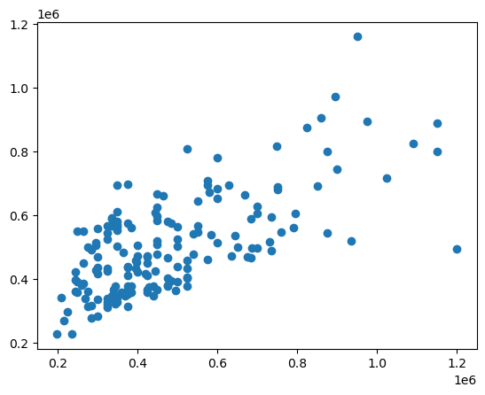

A scatter plot is created to visualize the relationship between the actual and predicted prices.

1. **Regression Evaluation Metrics**

from sklearn import metrics

print('MAE:', metrics.mean_absolute_error(y_test, prediction))

print('MSE:', metrics.mean_squared_error(y_test, prediction))

print('RMSE:', np.sqrt(metrics.mean_squared_error(y_test, prediction)))

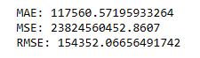

Various regression metrics are calculated and printed to evaluate the performance of the model.

This documentation provides a comprehensive overview of the Jupyter Notebook, including data preprocessing, exploratory data analysis, model training, and evaluation. It also includes interpretations of coefficients and visualizations for better understanding.